WINANT, John Gilbert (known as Gil), American politician and third Director of the International Labour Office of the International Labour Organization (ILO) 1939-1941, was born 23 February 1889 in New York City and passed away 3 November 1947 in Concord, New Hampshire, United States. He was the son of Frederick Winant, real estate broker, and Jeannette Laura Gilbert. On 20 December 1919 he married Constance Rivington Russell. They had one daughter and two sons.

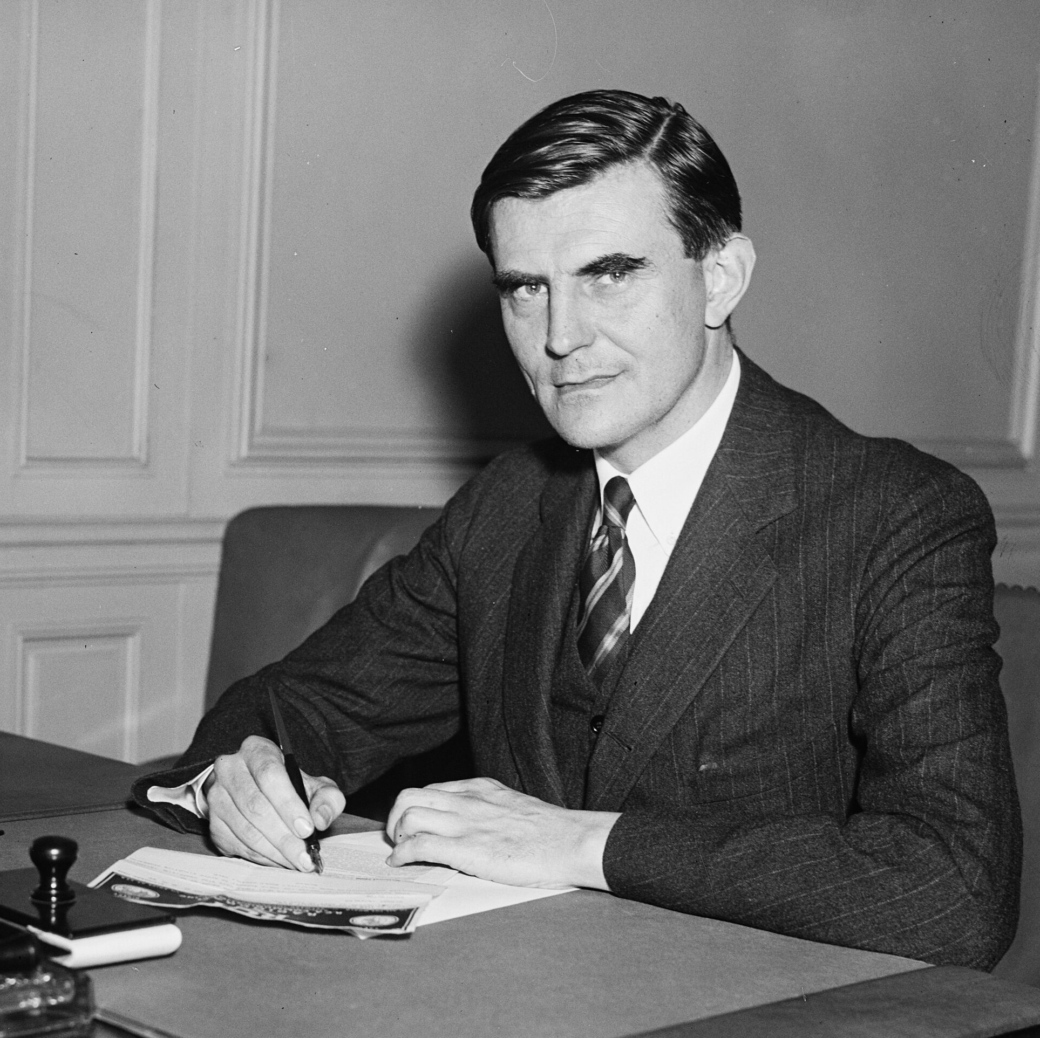
Source: Winant, 13 September 1935, Chairman of Social Security Board, New Hampshire, Photographer Harris & Ewing

Winant was the eldest of four sons and was raised in a conservative Republican upper-middle-class family in New York City, where his father was a partner in a real estate firm. He studied at St. Paul’s School in Concord, New Hampshire and at Princeton University in New Jersey, but was generally considered to be a weak student. It took him a year longer than expected to graduate from St. Paul’s and, after withdrawing and then returning to Princeton several times, he finally left the university in 1912 without completing his degree. Nevertheless, while at St. Paul’s and Princeton Winant showed signs of his interest in and talent for politics. He was influenced by writings of John Ruskin, enjoyed political biography and was involved in numerous school clubs. Upon graduation from St. Paul’s he received the School Medal for distinguished excellence in the performance of school duties and at Princeton he was active during the 1912 presidential campaign, embracing Theodore Roosevelt’s Progressivism. He was among the students who arranged Roosevelt’s visit to the university. In that year he also accepted an offer from the rector of St. Paul to return to his old school as a schoolmaster and personal assistant. In 1914 Winant ran as a Republican for a seat from the seventh Ward for the Lower House of the New Hampshire legislature. His father’s opposition to this idea led him to withdraw from the election, but he remained active in local politics. In 1916 he overcame his father’s opposition and successfully ran for the New Hampshire legislature. His success was in part due to the fact that, although running as a Republican, he expressed strong support for the labor unions in his Ward. In his short time in the legislature Winant became a recognized leader among the Republican Party’s progressive members. He supported bills that restricted the working week for women and children and regulated wage standards. In 1917, soon after the United States (US) entered the First World War, he resigned from St. Paul’s and the legislature and joined the Army Air Service as a private. During the war he became a pilot and, having advanced to the rank of captain, he commanded the 8th Aero Squadron, which performed air surveillance and reconnaissance in France.
After the war Winant returned as an instructor at St. Paul’s School. In 1919 he married Constance Russell, a wealthy socialite. While Winant cared little for the practicalities of money, his wife’s main interest was society life. Winant was a teetotaler and indifferent to food, often forgetting to eat. In 1920 he was elected for a seat on the New Hampshire Senate. In 1925 he was successful in his first bid to become governor of New Hampshire and he was the first New Hampshire governor to serve more than one two-year term (1925-1926, 1931-1932 and 1933-1934). As Governor, Winant became a strong supporter of workers’ rights, successfully addressing minimum wage, state relief and aid to dependent children. When the Depression hit in 1929, about one-third of New Hampshire workers became unemployed. In 1931 Winant designed the New Hampshire Plan, which established a four-day workweek and allotted the hours of the fifth day to the unemployed. Due to dissatisfaction with President Herbert Hoover’s restrained response to the crisis, he embraced Franklin Delano Roosevelt’s New Deal policies, despite the party and ideological differences between him and Roosevelt. In 1934, when Roosevelt sought to appoint a Chairman of the National Textile Inquiry Board, Winant was an obvious choice, given the face-saving settlement he had ensured in the textile workers’ strike in New Hampshire. That year Roosevelt also chose Winant as an Advisory Council member of the Committee on Economic Security, which was chaired by Francis Perkins and had a technical board headed by Arthur Altmeyer. Winant was the only government official to be appointed to this body that advised on ways to promote greater economic security.
After the US joined the International Labour Organization (ILO) in 1934, some of the major member states and, more importantly, the British Director of the International Labour Office, Harold Butler, sought to have an American take up the position of Assistant Director. The position had been left open after Nazi Germany left the organization in 1933. Butler felt that for the ILO to survive during the increasingly difficult times the organization required a strong US presence. Getting an American to take up the Assistant Director position was a difficult task, as the US continued to embrace a fairly isolationist foreign policy, avoiding the League of Nations as much as possible. However, Roosevelt, who had supported the ILO from the beginning (when he was Assistant Secretary of the Navy, he found premises for its first conference held in Washington DC in 1919), backed Butler’s plan and suggested Winant for the position of Assistant Director. Some believed that the president made his choice in order to keep Winant out of the 1936 elections, but those close to this decision denied it (Belush 1968: 110). As an officer of the American Association of Labor Legislation (which previously had been a member of the International Association of Labour Legislation, considered the ILO’s precursor) and as someone who had become very familiar with labor issues, Winant was aware and in admiration of the ILO’s work. Although he never publicly acknowledged it, some have suggested that he felt the ILO job would also help his potential bid for the presidency or vice-presidency in the 1940 US elections (Belush 1968: 111). In April 1935 he therefore accepted the post of Assistant Director, but did not take the oath of office, as it involved him declaring allegiance to both the ILO and the League, something he felt his fellow Republicans would never tolerate. Butler found a way around this by delaying his arrival to Geneva until after the Governing Body had met.
The first experience Winant had as an ILO official was brief, but led to some important developments. Involved with the 1935 International Labour Conference, which committed itself to the 40-hour workweek as an international standard, he made sure that the recently appointed New Deal representatives of the US government were present in order to demonstrate the newfound American commitment to the ILO. He also initiated the first regional conference of American member states, which eventually took place a few months after his first departure from the organization. By October 1935 Roosevelt, who spoke about Winant as Utopian John but also appreciated his organizational capacities, called Winant back to the US to take on the position of Chairman of the newly established Social Security Board. While Roosevelt wanted a sympathetic Republican as leader, Perkins expected him to provide the philosophical leadership that the new institution needed. In a speech explaining his departure from the ILO only a few months after taking on the position of Assistant Director, Winant explained that the simple adoption of labor legislation did not mean much unless there were ‘competent officials to administer and enforce the laws’ (Bellush 1968: 115). Many ILO officials, especially Butler, were disappointed with Winant’s departure, taking it as a sign of an already eroding US interest in the ILO.
Some saw Roosevelt’s selection, yet again, as a way for the standing president to isolate a potentially strong opponent from the Republican base. Even if this were true, and Winant indeed had higher political aspirations, he could not resist the opportunity to shape what he considered to be an important institution of social justice and he, therefore, accepted the position of Chairman of the Social Security Board. The first year of the new Board involved a great deal of work, in which he collaborated closely with Altmeyer. Winant and his colleagues needed to establish a national organization with twelve regional offices and 108 field offices and hire more than 4,000 individuals. During his time on the Board Winant maintained his contacts at the ILO. His former assistant in Geneva, Carol Riegelman, would send him ILO documents as well as lengthy letters describing the organization’s work. Winant invited ILO experts to Washington DC to advise him on the implementation of the Social Security Act. While traveling across the US as part of his work for the Board, he often spoke about the ILO to his audiences and in 1936 he was named Chairman of the US delegation to the International Labour Conference. When Butler visited the US in 1936 he was surprised to see how well Winant was aware of the ILO’s work and, therefore, asked him to keep an eye on the organization’s Washington office. When Republican presidential candidate Alf Landon called for the repeal of Roosevelt’s Social Security program, Winant decided to resign from the Board in September 1936 so he could freely speak out in support of the program, a position which isolated him even further from the Republican Party. After the election he again accepted the Board’s Chairmanship in order to break an impasse between the two other Board members, but then resigned once more in February 1937. Altmeyer succeeded him as Chairman.
A few months later, at Butler’s urging and with Roosevelt’s consent, Winant returned to his position as Assistant Director of the International Labour Office. Over the next two years Butler groomed Winant as his successor bringing him in on all major decisions. At the ILO, as in his previous administrative positions, Winant proved to be a workaholic, staying at his office late into the night and often skipping lunch. Although he expected his staff to also keep long hours, he was described as being generous with them, always making sure that they were compensated for their additional work. His generosity extended to subordinates who did not work directly with him, despite his own alleged personal financial problems. Winant surrounded himself with young people, was open to appointing women and influenced the hiring of American women after the US accession to the ILO. His egalitarian and casual style, which at the time was considered unusual for Geneva-based organizations, made him beloved by many of his subordinates and led them to be fiercely loyal to him. Others, however, saw his controversial approach to work in the ILO as chaotic and ineffective (Partington 2003). In 1938 Butler abruptly decided to resign as Director and worked hard to have Winant succeed him, even though the American was the least experienced of the candidates for the position. Assistant Director Edward Phelan, who had played a leading role in the establishment of the ILO and had since worked in the organization in various executive positions, was considered the strongest candidate. Perceived as someone who knew the organization very well, Phelan had a great deal of support from both the Office and national delegations. However, Roosevelt and his administration lobbied vigorously for Winant, which was unusual at the time, and the American was eventually elected Director, while Phelan was named Deputy Director. This time Winant took the ILO oath.
Winant served as Director of the International Labour Office for only two years, from 1 January 1939 to 15 February 1941. As those years coincided with the outbreak of the Second World War, he was faced with a myriad of unexpected problems. The first ones he had to deal with were financial in nature. The withdrawal of Germany, Italy and Japan from the League and the ILO had left these organizations with tremendous budgetary constraints. Soon after he took office, Winant had to release one eighth of the organization’s staff. In time, as the war progressed and the ILO’s financial problems were exacerbated, the organization’s staff was eventually reduced to only one fifth of its original headcount. Even before the war began, Winant understood that if the ILO were to survive the turbulent times, he needed to take some extraordinary measures. He decided to shed the usual impartiality that came with his position of international civil servant and rely on his American connections. He sought the financial and political support of the US president and the State Department and, in turn, did not make any important ILO decision without first consulting with his government. Thinking ahead to the potential problems the ILO could face, he asked the Governing Body to establish an Emergency Committee to take over the ILO’s governance in case of war. He also sought to slow down the advancement of the organization’s agenda and urged postponing the planned discussions during the 1939 Annual Conference of further reducing working hours. He felt that this issue could not be adequately resolved when states were operating their economies in preparation for war and, therefore, were likely to seek longer, rather than shorter, working hours. In his public speeches he also presented the ILO as a tool for democracy and, therefore, in his opinion, the organization needed to take sides in a conflict that was shaping to be one between democratic and undemocratic forces. In his 1939 Director’s Report Winant called for the ILO to prepare for the end of the war, when democratic states would be able to continue with their social objectives.
Despite his urging to postpone major labor agreements among states until after the war, Winant did not want the ILO to remain dormant during those years. He continued the work his predecessor had begun of tilting the balance of the organization even further towards the American continent. Although some of his close advisers counseled him to not push ahead with the organization of a second labor conference of American states at a time when military operations had begun unfolding in Europe, he convinced the now operational Emergency Committee to go ahead with his plans. The conference was held in November 1939 in Havana, Cuba, just when the Soviet invasion of Finland was unfolding. Winant also decided to move the organization’s headquarters to the other side of the Atlantic, at least for the duration of the war. In May 1940, when Germany began its invasion of France, he understood that Geneva would become increasingly surrounded by Axis troops and he began making plans for transferring the ILO. Initially Winant requisitioned space in Vichy, but the fall of France in June 1940 made this move impractical and he turned his aspirations to Washington DC. Despite opposition from some of his staff, including Phelan, and from some of the Emergency Committee, his proposal for a North American transfer eventually prevailed. While Roosevelt, counseled by Perkins, his Secretary of Labor, initially agreed to the move, the State Department fought this decision. Cordell Hull, the Secretary of State, believed that if the US allowed the ILO to move its staff to Washington, this would mean that a number of dubious nationals from Axis-dominated states would enter the country. Moreover, he felt that if the ILO was allowed to move to the US, the League of Nations might follow. Hull eventually convinced Roosevelt to refuse to allow the ILO’s move to the US. Encouraged by Wilfred Jenks, Legal Adviser of the ILO, Winant turned to the Canadian government, seeking refuge for the organization in that country. By July 1940 the Canadians consented to the transfer of the ILO to Montreal. The decision was kept secret until mid-August, while a core group of fifteen ILO staff members traveled to Lisbon via Grenoble and Madrid and then crossed the Atlantic by ship. Winant summarized his decision to move the ILO as his clear duty to avoid all danger that the ILO, ‘the repository of the traditions of a world-wide effort at tripartite international co-operation to promote social justice, should become the tool of political forces which would have attempted to use it as a mask for policies of domination rather than as a spearhead of social and economic freedom’ (International Labour Review, 1947, 532). The depleted ILO secretariat remained in Montreal, at McGill University, from September 1940 until mid-1948. Winant was not content with maintaining the ILO throughout the war simply as an institution collecting and disseminating information. In a November 1940 speech to the American Federation of Labor he called for the return of the ILO from the narrow intergovernmental character it had developed in the past few years to its original goals of meeting workers’ needs. Winant, however, was not able to pursue any sweeping changes to the organization because, by late 1940, he already had his eye on the prestigious and, at that time, extremely important position of US Ambassador to the United Kingdom (UK). Therefore, in his last few months as ILO Director not only did Winant become less involved with the work of the organization, but he even opposed holding an International Labour Conference that had been promoted by many of his advisers. In February 1941 Winant left for London as US Ambassador, replacing Joseph P. Kennedy. The ILO Governing Body then elected Phelan as Acting Director.
As Ambassador, Winant was able to change the main direction of American policies towards the UK as well as the style associated with this high-status position. He was instrumental in shifting US policies from ones of German appeasement that had been supported by his predecessor, to ones of strong pro-British support. He advocated greater aid to the UK and the Soviet Union before the US entered the war. During the Battle of London’s air raids Winant was often seen walking the streets, offering help to those who needed it. He preferred staying in a small flat in the embassy rather than the opulent Ambassador’s residence in order to be close to his office since his job required 24-hour duty. Given the close relationship between Roosevelt and British Prime Minister Winston Churchill, he took care of an extensive exchange of information between the US and the UK. When both leaders designed the Atlantic Charter in 1941, they accepted his suggestion to also include a call for social insurance (the fifth principle). Brought in by Deputy Prime Minister Clement Attlee, Winant told English coal miners in Durham in June 1942 that their strike plans had to be seen relative to the life-or-death struggle to preserve democracy, thus deepening the war’s meaning in its relation to improving economic circumstances. In November 1943 Winant became US representative to the European Advisory Commission, which discussed postwar planning, including the position of Germany. Winant developed a warm friendship with Churchill and his family, who he would visit regularly during the weekends. Winant’s marriage strained and he had a love affair with Churchill’s daughter Sarah, which they managed to keep secret. While he wanted to divorce, Sarah declined. When Roosevelt passed away in April 1945, Winant lost his political mentor and in March 1946 President Harry S Truman appointed a new ambassador. When Winant left his position in London he was very popular with the British people and he became one of only two American citizens, the other being Dwight D. Eisenhower, to receive the prestigious British Order of Merit.
Winant had hoped to become the first Secretary-General of the new United Nations (UN), but when it became apparent that this position would not go to an American, President Truman appointed him to the UN Economic and Social Council in early 1946, where he dealt with refugees, displaced persons and other postwar issues. After less than one year holding this position, Winant resigned in January 1947 and withdrew to Concord, New Hampshire where he began writing his multi-volume memoirs. He also chaired the National Brotherhood Week in February, which included an exhausting cross-country speech-making tour. Unable to adjust to a life outside the public arena, he found a life of leisure to be depressing. He managed to complete work on the first volume of his memoirs, but on the day it was published in November 1947 he took his own life at the age of 58. Because of his suicide he was not buried on the grounds of St. Paul’s, but in 1968 his casket was moved there. In 2015 fundraising began for a bronze statue of Winant in front of the New Hampshire State Library in Concord.

ARCHIVES: Papers relating to Winant’s service as International Labour Office Director are located in the ILO Archives in Geneva, Switzerland. Winant’s personal papers were donated to the Franklin D. Roosevelt Library and Museum in Hyde Park, New York, see www.fdrlibrary.marist.edu/archives/pdfs/findingaids/findingaid_winant.pdf.
PUBLICATIONS: Rapport présenté aux gouvernements, aux employeurs et aux travailleurs des états membres de l’Organisation internationale du travail, Montreal 1941; International Relations, Leeds 1942; The Economic and Social Council of the United Nations: Report to the Secretary of State, Washington DC 1946; Letter from Grosvenor Square: An Account of a Stewardship, Boston 1947 (reprinted Santa Barbara 1969); Franklin Delano Roosevelt: Memorial Address Delivered before the Joint Meeting of the two Houses of Congress as a Tribute of Respect to the Late President of the United States … July 1, 1946, Washington DC 1948; Our Greatest Harvest: Selected Speeches, 1941-1946, London 1950.
LITERATURE: The New York Times, 4 November 1947; ‘John Gilbert Winant’ in International Labour Review, 56/5, November 1947, 527-532; E. McLean Johnson, The Mr. Winant I Knew, Washington DC 1949, also in South Atlantic Quarterly, 48, Winter 1949, 24-41; A. Knepper, John Gilbert Winant and International Social Justice, New York 1955 (dissertation New York University); B. Bellush, He Walked Alone: A Biography of John Gilbert Winant, The Hague 1968; D. Morse, The Origin and Evolution of the ILO and Its Role in the World Community, New York 1969; A.E. Alcock, History of the International Labour Organisation, New York 1971; W. Galenson, The International Labor Organization: An American View, Madison 1981; B. Belush, ‘Winant, John Gilbert’ in W.F. Kuehl (Ed.), Biographical Dictionary of Internationalists, Westport 1983, 788-790; N.D. Howland, Ambassador John Gilbert Winant: Friend of an Embattled Britain, 1941-1946, College Park 1983 (dissertation University of Maryland); L. DeWitt, ‘John G. Winant: First Chairman of the Social Security Board’ in Social Security Special Studies, nr. 6, May 1999, available at www.ssa.gov/history/mywinantarticle.html; J.O. Freedman, ‘John Gilbert Winant: Brief Life of an Exemplary Public Servant: 1889-1947’ in Harvard Review, 1 November 2000, available at http://harvardmagazine.com/2000/11/john-gilbert-winant.html; G. Partington, ‘John Gilbert Winant at Geneva: The Testimony of Sir Walter Crocker’ in National Observer, nr. 58, Spring 2003, 49-61, available at www.nationalobserver.net/2003_spring_110.htm; S. Hughes and N. Haworth, ‘A Shift in the Centre of Gravity: The ILO under Harold Butler and John G. Winant’ in J. van Daele et al. (Eds), ILO Histories: Essays on the International Labour Organization and its Impact on the World During the Twentieth Century, Bern 2010, 293-311; G. Rodgers, The International Labour Organization and the Quest for Social Justice, 1919-2009, Geneva 2009; J. Hare, ‘Eventually, Winant Ended Up at St. Paul’s’ in Concord Monitor, 5 February 2010; D. Dexter, ‘John Gilbert Winant Finally Gets his Dues’ in Laconia Daily Sun, 11 February 2010, available at www.nhcommentary.com/john_gilbert_winant_finally_gets_his_due.htm; J. Milne, R. Kinhan and G. Forester, Crosscurrents of Change: Concord, New Hampshire in the Twentieth Century, Concord 2011; G. Garrison, ‘Foreign Aid: John Gilbert Winant’ in Finest Hour, nr. 153, Winter 2011-2012, 38-46, available at www.winstonchurchill.org/publications/finest-hour/finest-hour-153/foriegn-aid-john-gilbert-winant; D. Mayers, ‘John Gilbert Winant, 1941-46’ in A. Holmes and J. Rofe (Eds), The Embassy in Grosvenor Square: American Ambassadors to the United Kingdom, 1938-2008, London 2012, 49-63; J. Pearson, The Private Lives of Winston Churchill, London 2013; J.L. Eisenberg, American Women and International Geneva, 1919-1939, Geneva 2014 (thesis Graduate Institute); L. Olson, Citizens of London: The Americans Who Stood with Britain in Its Darkest, Finest Hour, Brunswick 2015; ‘The Tragic Love Affair of Former NH Gov. John Winant and Sarah Churchill’, 14 May 2015, available at www.newenglandhistoricalsociety.com/tragic-love-affair-former-nh-gov-john-winant-sarah-churchill/; ‘John Gilbert Winant’, available at www.concordhistoricalsociety.org/john-gilbert-winant/; ‘John G. Winant’, available at www.ilo.org/global/about-the-ilo/how-the-ilo-works/ilo-director-general/former-directors-general/WCMS_192710/lang--en/index.htm; ‘John Winant’ in World War II Database, available at http://ww2db.com/person_bio.php?person_id=655 (all websites accessed on 21 August 2016).

Alexandru Grigorescu

Version 19 September 2016

How To Cite This IO BIO Entry?
Alexandru Grigorescu, ‘Winant, John Gilbert’ in IO BIO, Biographical Dictionary of Secretaries-General of International Organizations, Edited by Bob Reinalda, Kent J. Kille and Jaci L. Eisenberg, www.ru.nl/fm/iobio, Accessed DAY MONTH YEAR

